**Mobile App**

Project Proposal

Nottingham Trent University

Final Year Project

Contents

Abstract 3

Aims and Objectives 3

Task and deliverables 3

Literature Review 3

Comparison 3

Legal, Social, Ethical and Professional Issues (LSEPIs) 3

References 4

# Abstract

# Aims and Objectives

# Task and deliverables

# Literature Review

* Talk about the issue relating to the project (compare nhs old research to new research + stats)

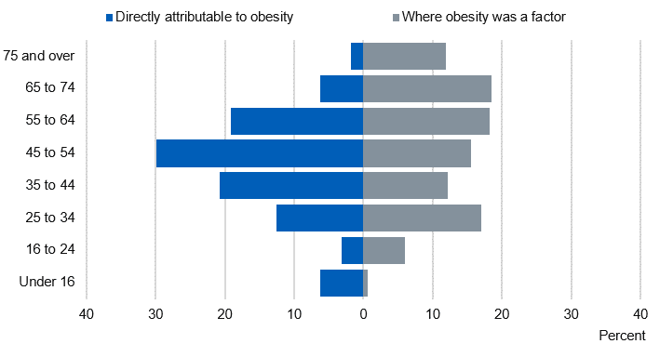The project will tackle physical health issues in the UK due to lack of exercise. According to the research done by NHS (July 2012), a lot of health issues in the UK are due to the lack of exercise which is “as deadly as smoking”. It has been estimated that “one in 10 cases of heart disease (10.5%) and just under one in five cases (18.7%) of colon cancer in the UK” often can be due to lack of exercise. In 2008, inactivity caused more than 5.3 million of the 57 million deaths estimated worldwide (NHS 2012). Lack of exercise can also cause your bones to become weak, risk of diabetes or hypertension (Kristin Davis, n.d). However, over the years, health issues relating to lack of exercise didn’t decrease; obesity being one of the main concerns. In a very recent article by NHS (May 2019), during 2017/18, there were 10,660 patient admissions who had illnesses directly relating to obesity and 711,000 where obesity was “primary or a secondary diagnosis”; which is very similar to the statistic recorded in 2016/17 (10,705). Obesity was more common in female adults than it was in male adults. For every 4 patients, 3 were female (74%) for illnesses directly relating to obesity, and around 2 in every 3 (66%) for illnesses that had some relation to obesity. The statistics show that obesity was commonly found in adults aged between 35-64.

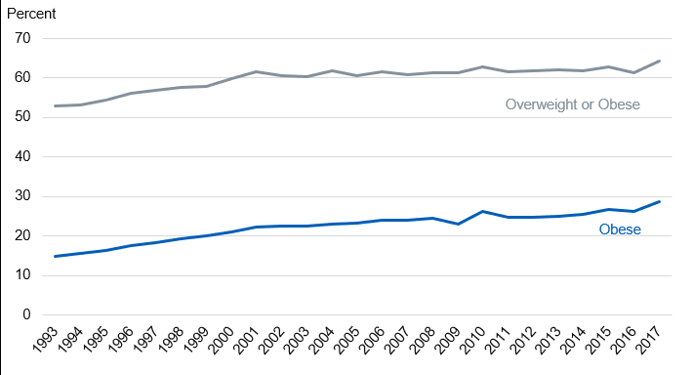“The majority of adults in England in 2017 were overweight or obese (64%)” and the percentage of obese adults was “29% higher than in recent years” (NHS 2019). The percentage of obesity increased “steeply between 1993 and around 2000” in England, however, the rate of increase became slower after that. This suggests that despite NHS knowing the increase of obesity throughout UK for a very long time, and researchers having come up with solutions to tackle this issue, they couldn’t decrease the amounts of patients being admitted into hospitals due to obesity; instead the numbers were gradually increasing with time – nonetheless, they did manage to slow it down in recent years. The research showed that not only adults are at risk of being diagnosed with physical health illnesses such as obesity, but young children too. The same article stated that in 2017/18 prevalence of obesity in year 6 children has increased by 1% compared to 20.0% in 2016/17. For children in reception the percentage didn’t change much and was “similar at 9.5% in 2017/18”. However, compared to 2006/07 the percentage is lower for children in reception but is higher for kids in year 6 (NHS 2019).

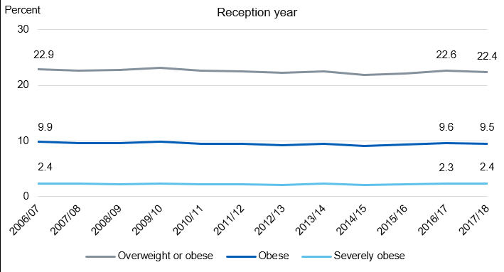 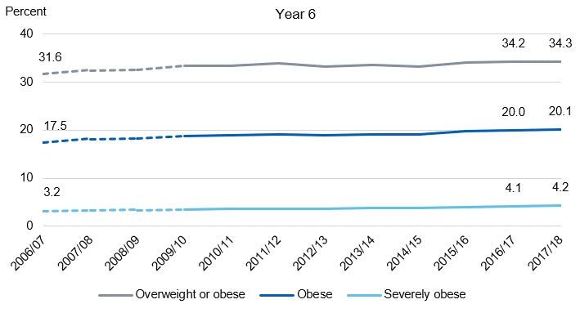

* Talk about Health Risks Associated with Obesity such as, risks of increasing cancer, Heart disease, diabetes,
* Talk about how technology trying to tackle the issues
* Talk about current solutions
  + Exergames (some require and monitor and some don’t)
    - Wii Fit
    - PS4 Kinect
    - Just Dance
  + Smart Watch
    - Promotes healthy lifestyle
    - Keeps track of your performance (heart rate, calories burned etc)
    - Multifunction (watch + fitness tracker)
* Narrow it down to mobile specific (e.g. Pokémon Go)
  + Current mobile related applications which tackle same issue
    - **active notts**

Active notts is a website which contains information on every sport/physical activity to help people with their health issues. It allows the user to search for the sport by typing the name of the sport in the search bar, alternatively, they can search for sports which can help them with their certain health conditions. For example, they can type ‘Mental health’ in the search bar and the website will display every sport which can be useful for people with mental health. When the user clicks on the sport, the website displays an overview of the chosen sport which can be very useful for people who are not familiar with the sport. It also displays benefits of the chosen sport, costs which the user may need to take into consideration (e.g. equipment, kit etc), how to get involved/started, equipment the user will need and interesting facts about the sport. At the bottom of the page, users can search for opportunities available in their area (or within their chosen radius) where the website will display all the clubs/facilities available for the sport. The user can filter the search result by date, gender, skill level, age range, family friendly, disability etc. When the user clicks on the club/facility, the website will then display brief description of the club, contact details, and the location. The website doesn’t just contain information about all type of sports but physical activities as well. It displays a variety of activities from chair-based exercises, Walking, Gardening, Yoga to CrossFit, Dance and Qigong etc. When the user clicks on activities, they process and options they are given are the same as when they click on a sport, as they can search for opportunities, filter them etc.

(talk about strength/weakness? Comparison?)

* + - Find a Player

‘Find a Player’ is a mobile application designed to help encourage people who are not part of sport clubs to get involved by helping them find new clubs they can join for those interested in playing weekly at a competitive level. However, for players interesting in playing in their spare time as a hobby, ‘Find a Player’ allows the user to find local players for their team (i.e. 5-a-side football match or any sport) if they are short on numbers, and vice versa, they can join a team for a quick game of their chosen sport. The user can approve or decline applicants by viewing their application. This is possible as users can create their own profile where they include brief information about themselves; this also allows others to add you as their friends and vice versa. ‘Find a Player’ also lets the players to rate one another which allows other users to determine someone’s skill level. This makes is easier for users to review applicants. This application isn’t targeted towards individual players, but towards organisers and clubs too as it allows them to register their clubs or advertise sport events and recruit players or teams. ‘Find a player’ also has a message feature where you can talk to a player individually or create a group chat. This application is available on Android as well as IOS devices.

* + - Playwaze
    - Sportyapp
    - Teamapp
    - Endomondo
    - Playo
    - GW Sports App
    - Pokémon Go
    - Yoga studio
    - Just 6 weeks
    - Fitbit
    - Superhero Workout
* Compare it with my project and how it’s different yet similar – how will it help with the issue

## Comparison

|  |  |  |  |
| --- | --- | --- | --- |
| **Name** | **Features** | **Strengths** | **Weaknesses** |
| active notts | * Can search for any sports (A-Z) * Gives overview of the chosen sport * Lists health benefits related to it * General costs the player may need to consider (hiring out a court etc) * Equipment required to play the sport * An interesting fact related to the sport * Locates clubs related to the chosen sport within the specified distance * Shows the location on the map * Information/Contact details of the club * Location of local venues * Users can filter their search (age, disability, gender etc) | * Gives brief description about the chosen sport which is useful for beginners * Helps identify any costs the player may need to cover which can be difficult to know for someone new to the sport * Shows location of the club on the map + contact details so if the person has any enquiries, they can contact them or visit them in person * There is a filter option for people with disability so they can search for clubs which will suit their needs * Search for the sports associated with wellbeing keywords. i.e if they search of “mental health” the website will display all sports that can be helpful for people with mental health issues |  |
| Find a Player |  |  |  |
| Playwaze |  |  |  |
| Sportyapp |  |  |  |
| Teamapp |  |  |  |
| endomondo |  |  |  |
| Playo |  |  |  |
| GW Sports App |  |  |  |
| Pokémon Go |  |  |  |
| Yoga Studio |  |  |  |
| Just 6 weeks pro |  |  |  |
| Fitbit |  |  |  |

# Legal, Social, Ethical and Professional Issues (LSEPIs)

# References

nhs.co.uk. (2012). Lack of exercise as 'deadly' as smoking. [Online]. [21 October 2019]. Available from: https://www.nhs.uk/news/lifestyle-and-exercise/lack-of-exercise-as-deadly-as-smoking/

Davis, K. (n.d.). The Effects of Lack of Exercise on the Body | Livestrong.com. [online] LIVESTRONG.COM. Available at: https://www.livestrong.com/article/351679-the-effects-of-lack-of-exercise-on-the-body/ [Accessed 28 Oct. 2019].

National Health Service, N.H.S. 2019. Statistics on Obesity, Physical Activity and Diet, England, 2019. [Online]. [4 December 2019]. Available from: https://digital.nhs.uk/data-and-information/publications/statistical/statistics-on-obesity-physical-activity-and-diet/statistics-on-obesity-physical-activity-and-diet-england-2019/introduction